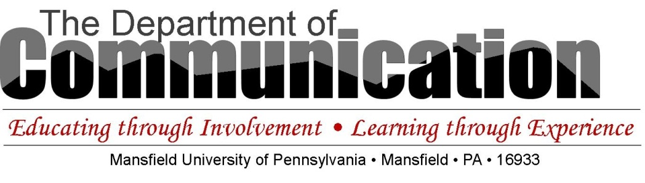
Northern Appalachian Storytelling Scholarship
The Northern Appalachian Storytelling Festival celebrated the oral narrative tradition through its annual festivals at MU for 21 years. The NASF presents this storytelling scholarship so that the narrative tradition will continue to be encouraged at the University. This scholarship is intended to assist students who are majors in The Department of Communication and value the storytelling tradition.

Cover Page:

Name of Applicant: ________________________________
Email Address: ________________________________
Credits earned: ________________________________
GPA (must be 2.7+): ________________________________

Criteria:
- Engaging plot
- Interesting characters
- Interesting theme
- Clear structure
- No writing or proofreading errors

When you complete this application, print it, and take it to Jocelyn Brion in 119Allen. She will remove the cover sheet and give your submission a code. Please do not refer to your name in your application.

Applicant Code (to be filled out by Jocelyn Brion, Department Office Assistant): ___________________

Applicant Code (to be filled out by Jocelyn Brion, Department Office Assistant): ___________________

NASS--APPLICATION
Statement of interest in storytelling as a narrative tradition (use as much space as necessary):

Statement of how you are a positive representative of the department within the campus community (use as much space as necessary):

Attach an original story (600-750 words). Develop an engaging theme, plot, characters in a structured story with a beginning, middle, and end. Pay attention to grammar and spelling. We disqualify applications with errors.
_____Fiction
_____Non-fiction
_____Word Count

