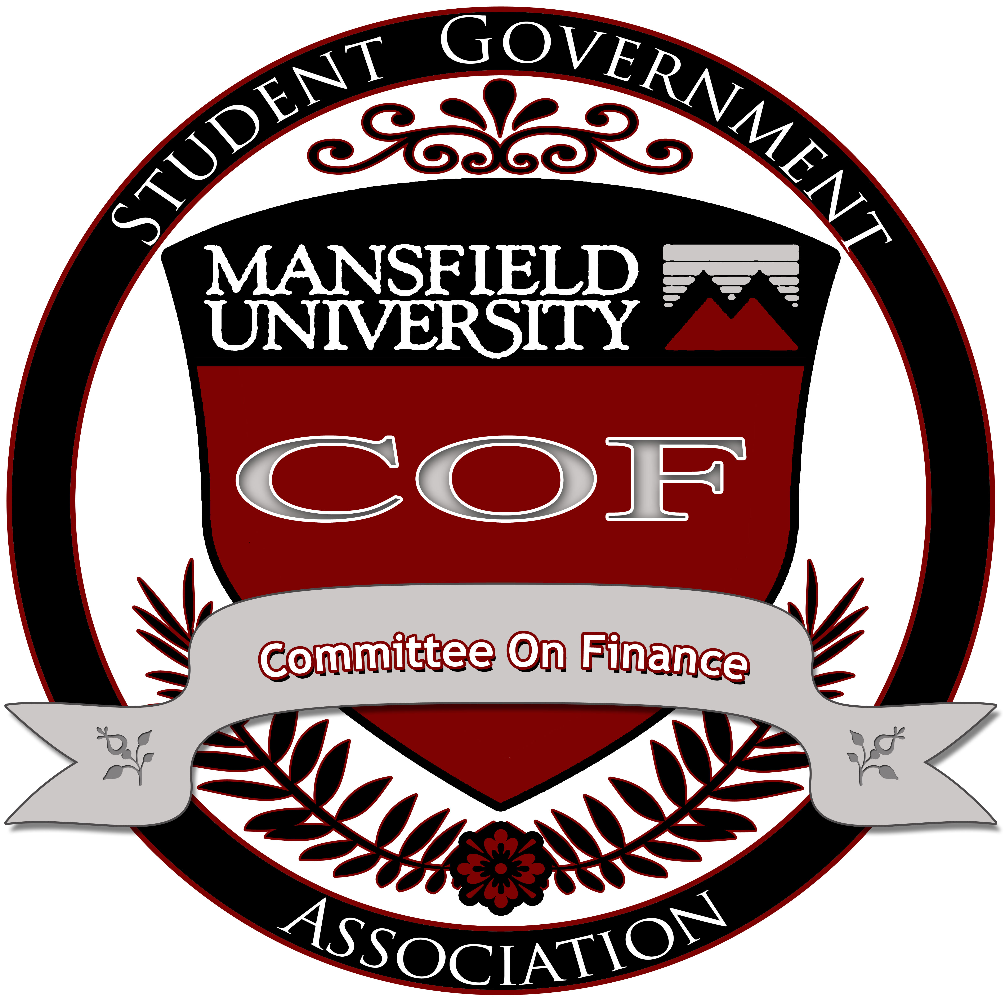

Committee on Finance
Budget Hearings Minutes
March 8, 2014

- Call to order: 9:23am
- Attendance Report: Alexander Farley
  - Voting Members: 6
  - Non-voting Members: 3
- Chair Report: Jason A. White
  - 55 organizations submitted budget materials.
  - 50 organizations submitted budget requests in the required format and by the deadlines set by the Committee on Finance and are therefore going to be entertained by this committee.
  - The dollar amount of the total request Student Organization Budgets is: $2,471,493.91
    - This puts the Student Organization Budgets at $371,493.00 over the $2,100,000.00 available total for Student Organization Budgets.
- Old Business
  - N/A
- New Business
Budget Criteria is as follows:
Committee on Finance Funding Request Approval Criteria:

- Does the organization meet the eligibility requirements?
- Does the organization actively recruit members?
- Does the organization have an active roster with attendance records?
- Does the organization conduct fund-raising activities to supplement their allocated budget?
- Does the organization participate in community service events?
- Is the funding request clear, complete, precise, and appropriately prepared?

If the answer to any of #1- #6 is no: request denied in full

- Will the events, programs, or service sponsored by the organization be effective?

Criteria to be considered when assessing “effectiveness”
  - Will a large number of students be positively affected by the event, program, or service?
  - Will the event, program, service be significant, profound, or of vital importance to the participants?
  - Will the event, program, service be academic or professionally relevant in nature?
  - Will the event, program, service be culturally enriching in nature?
  - Will the event, program, service be provide a specific service to the university
  - What will the students who participate in this event, program, service bring back to the University as a result? In other words, what is the "take back" - especially for conferences and other travel requests. (examples: spirit, recruitment, SPECIFIC retention plans, community building)

  - Motion to set budget limit to 2 million due to declining enrollment
    - So moved: Alexander Farley-
    - Second: Michelle
      - Approved: unanimously

  - MTA: A science and art publication $3,614.00
    - Rebecca
    - Second: Michelle
    - Motion to cut refreshments to 2 months of total $100: Alex Farley
      - Second: Michelle
      - Passes: unanimously
    - Motion to approve $3,614.00
      - Passes: unanimously
  - MTA: American Choral Directors
    - Rebecca
    - Second: Michelle
    - Motion to friendly amend guest speakers to keep the 4 speakers at only $50 per person: Rebecca Adams
      - Call to question
        - Passes: unanimously
      - Fails
    - Motion to strike line 11 The American Spiritual ensemble
      - Alex Bock
      - Second: Alex Farley
      - Passes: 5
      - Opposed: 1
        - Passes
    - Motion to strike line 17 receptions
      - Alex Bock
      - Second: Alex Farley
      - Passes: unanimously

    - Motion to strike line 5 of travel: ACDA conference
      - Alex Bock
      - Second: Michelle
      - Passes: unanimously
    - Motion to strike line 5 of capital
      - Alex Bock
      - Second: Alex Farley
      - Passes: unanimously
    - Motion to approve $9,256.00
      - Passes: unanimously
  - MTA: American String Teachers
    - Rebecca Adams
    - Second: Alex Bock
    - Motion to strike line 14 in program: Sybarite 5 string quintet
      - Alex Bock
      - Second: Alex Farley
      - Passes: unanimously
    - Motion to strike line 19 in programming: time for three string trio
      - Alex Bock
      - Jared Berken
      - Passes: unanimously
    - Motion to strike line 5 in Travel: National ASTA Conference
      - Alex Farley
      - Alex Bock
      - Passes: unanimously
    - Motion to strike line 9 in capital: Receptions for orchestra concerts
      - Alex Bock
      - Michelle
      - Passes: unanimously
    - Motion to approve $2,330.00
      - Passes: unanimously
  - MTA: Art acquisition/ exhibition
    - Rebecca
    - Second: Michelle
    - Motion to strike all of capital
      - Alex B
      - Alex F
      - Passes: unanimously
    - Motion to strike lines 53-54 in programming: Annual art acquisition for the University art collection
      - Rebecca
      - Second: Jared
      - Passes: unanimously
    - Motion to strike lines 60-63 in programming: opening receptions for exhibitions
      - Alex F
      - Second: Michelle
      - Passes: unanimously

    - Motion to strike lines 50 in programming: Holiday Bazaar fundraising event and material costs and essentials for the event
      - Alex F
      - Second: Michelle
      - In favor: 3
      - Opposed: 3
      - Passes: Chair decides
    - Motion to strike line 5, 15, 35,44: Guest lecturers
      - Alex B
      - Second: Alex F
      - Passes: unanimously
    - Motion to approve $13,042.00
      - Passes: unanimously
  - Motion to approve Art and Guild Design
    - Rebecca
    - Second: Michelle
    - Motion to strike line 14 in travel: NYC
      - Alex B
      - Second: Alex F
      - In favor: 5
      - Abstained: 1
      - Passes
    - Motion to approve $5,150.00
      - Passes: unanimously
    - Motion to revisits
      - Alex B
      - Second: Rebecca
      - Motion to strike line 9 in programming: Semester parties
        - Alex B
        - Second: Tori
        - In favor: 5
        - Abstained: 1
        - Passes
    - Motion to approve the new amount of $4,890.00
      - In favor: 5
      - Opposed: 1
      - Passes
  - Bass Fishing was not be entertained due to lack of fund raising
  - Motion to approve Biology Club
    - Rebecca
    - Second: Alex B
    - Motion to strike line 5 in Travel: Boston, MA
      - Alex B
      - Second: Alex F
      - Passes: unanimously
    - Motion to amend totals of line 6 to $200 to $10 per shirt in programming
      - Michelle
      - Second: Tori
      - Passes: unanimously
    - Motion to approve $600
      - Passes: unanimously
  - Motion to Approve BSU
    - Rebecca
    - Second: Alex B
    - Motion to strike line 10, 55 in programing: Freshman night, American Spiritual Ensemble
      - Alex B
      - Second: Jared
      - Passes: unanimously
    - Motion to strike line 5,7,49 in programing: Car smash, Italian ice Social, and Speaker
      - Alex B
      - Second: Alex F
      - Passes: unanimously
    - Motion to strike 5 in Travel: Skating
        - Tori
        - Second: Michelle
        - Passes: Unanimously
    - Motion to strike line 10 in Travel: Broadway play
      - Tori
      - Second: Michelle
      - Passes: unanimously
    - Motion to strike line 14 in Travel: BSU national conference
      - Tori
      - Second: Michelle
      - In favor: 4
      - Opposed: 2
      - Passes
    - Motion to remove time limit for 10 minute cap for BSU
      - Alex F
      - Second: Tori
      - Passes: unanimously
    - Motion to strike line 29 in Travel: Spring Trip
      - Alex F
      - Second: Tori
      - Passes: unanimously
    - Motion to strike all capital
      - Alex F
      - Second: Alex B
      - Passes: unanimously
    - Motion to strike line 15 in programming: Supplies for fundraising
      - Michelle
      - Second: Tori
      - Passes: unanimously
    - Motion to strike line 16 in programming: shirts
      - Alex F
      - Second: Michelle
      - Passes: unanimously
    - Motion to strike line 29, 31 in programming: Food
      - Alex F
      - Second: Tori
      - In favor: 1
      - Opposed: 5
      - Fails
    - Motion to strike line 54 in Programming: Shirts
      - Rebecca
      - Second: Tori
      - Passes: unanimously
    - Stipulation that line 47 must be Julian Bond
    - Motion to strike line 27, 33, 40, 50 in programming: equipment handlers
      - Alex B
      - Second: Alex F
      - Passes: unanimously
    - Motion to strike line 43, 45 and amending line 42 to $300 in programming: Fashion Show
      - Rebecca
      - Second: Tori
      - Passes: unanimously
    - Motion to approve $24,775.00
      - Passes: unanimously
  - Motion of privilege
    - Alex F
    - Second: Michelle
  - Boxing club was not entertained due to not to fundraising, community service, and programming and didn’t fill out the word document
  - MTA: Catholic Student Association

    - Rebecca
    - Second: Alex B
    - Motion to strike lines 16 in programming: food
      - Alex B
      - Second: Michelle
      - Passes: unanimously
    - Motion to strike line 10 in programming: Food
      - Michelle
      - Second: Alex B
      - Passes: unanimously
    - Motion to strike line 11 in programming: DVD and Study materials
      - Rebecca
      - Second: Tori
      - In favor: 5
      - Opposed 1
      - Passes
    - Motion to strike line 14 in programming: food
      - Alex F
      - Second: Alex B
      - Passes: unanimously
    - Motion to approve $ 3,128.00
      - Passes: Unanimously
  - Motion to Cheerleaders
    - Rebecca
    - Second: Michelle
    - Motion to approve $ 1,118.00
      - Passes: unanimously
  - Motion to approve Chemistry
    - Rebecca
    - Second: Alex F
    - Motion to strike line 5 in programming: recruitment party
      - Alex F
      - Second: Alex B
      - Passes: unanimously
    - Motion to strike line 5 in Travel: American Chemical Society Meetings
      - Michelle
      - Second: Alex F
      - Passes: unanimously
    - Reinstate line 7 to $480: Vans
      - Alex F
      - Second: Tori
      - Passes: unanimously
    - Motion to strike line 8 in Travel: Spring gathering
      - Michelle
      - Alex B
      - Passes: unanimously
    - Motion to approve $2,075
      - Passes: unanimously
  - MTA: college against cancer
    - Rebecca
    - Second: Alex B
    - Motion to strike line 13 in programming: Food
      - Alex B
      - Second: Alex F
      - Passes: unanimously
    - Motion to strike line 28 in programming: car smash
      - Alex F
      - Second: Tori
      - Passes: unanimously
    - Motion to strike line 18 in programming: Workshop
      - Alex B
      - Second: Alex F
      - Passes: unanimously
    - Motion to strike line 27, 39 in programming: Prizes
      - Alex B
      - Second: Alex F
      - Passes: unanimously
    - Stipulation that all prizes come from the campus bookstore
      - Alex F
      - Second: Rebecca
    - Motion to strike line 51 in programming: Prizes
      - Alex B
      - Second: Tori
      - Passes: unanimously
    - Stipulation can only spend up to $10 per shirt and must be from the campus bookstore
      - Michelle
    - Motion to strike line 92 in programming: food/ beverage
      - Alex F
      - Second: Michelle
      - Passes: unanimously
    - Motion to approve $ 9,605.00
      - In favor: 0
      - Opposed: 6
      - Fails
  - Collegiate Entrepreneurs was not entertained due to lack of fundraising, community service, and programming
    - Rebecca
    - Second: Alex F
  - MTA: Computer Science
    - Rebecca
    - Second: Michelle
    - Motion to strike line 5, 9 in programing: food
      - Alex B
      - Second: Alex F
      - Passes: unanimously
    - Motion to strike line 14 in Travel: LAHacks
      - Alex B
      - Second: Michelle
      - Passes: unanimously
    - Motion to strike, 5, 12, 25, 28, 29, 30, 31, 32, 33, 34, 41 in capital: Games
      - Alex B
      - Second: Tori
      - Passes: unanimously
    - Motion to strike 9 in Travel: PACISE conference
      - Alex B
      - Second: Rebecca
      - Passes: unanimously
    - Motion to strike line 38 in capital: posters
      - Alex B
      - Second: Michelle
      - Passes: unanimously
    - Motion to approve $5,388.00
      - In favor: 5
      - Opposed: 1
      - Passes
  - MTA: Council for exceptional children
    - Tori
    - Second: Michelle
    - Motion to strike travel budget
      - Tori
      - Second: Alex B
      - Passes: unanimously
    - Motion to strike line 16 in programming
      - Alex B
      - Second: Alex F
      - Passes: unanimously
    - Motion to approve $1,075.00
      - Passes: unanimously
  - Dance team was not entertained due to lack community service
  - MTA: Double Reed Society
    - Tori
    - Second: Michelle
    - Motion to approve $1,090.10
      - Fails
  - MTA: ENACTUS
    - Tori
    - Second: Jared
    - Motion to strike line 11 in Travel: Fall leadership training conference
      - Tori
      - Second: Alex B
      - Passes: unanimously
    - Motion to strike line 10 in programing: Prezzi
      - Alex F
      - Second: Rebecca
      - In favor: 5
      - Opposed: 1
      - Passes
    - Motion to amend the amount the line 6 in Travel to $1500: Regional Competition
      - Michelle
      - Second: Tori
      - Passes: unanimously
    - Motion to strike line 24: 1890’s weekend
      - Alex F
      - Second: Michelle
      - In favor: 1
      - Opposed: 5
      - Fails
    - Motion to approve $4,051.82
      - In favor: 5
      - Opposed: 1
      - Passes
  - MTA: Fire ferrets (quidditch)
    - Tori
    - Second: Alex B
    - Motion to strike line 10 in capital: individual dues
      - Alex B
      - Second: Alex F
      - In favor: 3
      - Opposed: 3
      - Passes- chair decides
    - Motion to approve $6,667.50
      - Passes: unanimously
  - Fishier and aqua culture was not entertained due to lack of fund raising
  - MTA: Garden Club
    - Tori
    - Second: Michelle
    - Motion to approve $ 2,499.84
      - Fails
  - GLO was not entertained due to lack of community service
  - MTA: Geography Club
    - Tori
    - Second: Alex F
    - Motion to approve $ 6,097.58
      - Fails
  - MTA: Geology Club
    - Michelle
    - Second: Alex B
    - Motion to strike line 5, 31, 37 in Travel: Adirondack trip, West Virginia, spring break
      - Alex B
      - Second: Michelle
      - Passes: unanimously
    - Call to question
      - Alex B
      - Second: Alex F
      - Passes: unanimously
    - Motion to approve $3,460.84
      - Fails
  - MTA: History club
    - Tori
    - Second: Michelle
    - Motion to strike line 15 from travel: Spain and Portugal
      - Alex B
      - Second: Alex F
      - Passes: unanimously
    - Motion to strike programming: pizza
      - Tori
      - Second: Alex F
      - Passes: unanimously
    - Motion to approve $1,867.00
      - In favor: 5
      - Opposed: 1
      - Passes
  - MTA: Honors association
    - Tori
    - Second: Michelle
    - Motion to strike line 6 in programing: food/ beverages
      - Alex F
      - Second: Tori
      - Passes
    - Motion to strike line 7 in programming: food/ beverages
      - Alex F
      - Second: Alex B
      - Passes
    - Motion to strike line 24 in Travel: Boston, Ma
      - Alex B
      - Second: Alex F
      - In favor: 4
      - Abstained: 2
      - Passes
    - Motion to strike line 15, 18 in Travel: Skating
      - Tori
      - Second: Alex F
      - Passes: unanimously
    - Motion to approve $ 1,194.80
      - In favor: 4
      - Abstained: 2
      - Passes
  - MTA: Horn Club
    - Tori
    - Second: Michelle
    - Motion to approve $16,840.00
      - Fails
  - MTA: Hula hoop
    - Tori
    - Second: Alex B
    - Motion to strike line 6, 10 from programming: Professional DJ
      - Tori
      - Second: Alex F
      - Passes: unanimously
    - Motion to strike line 5 in capital and line 5 in Travel
      - Alex B
      - Second: Tori
      - Passes: unanimously
    - Motion to approve $445.00
      - In favor: 5
      - Opposed: 1
      - Passes
  - MTA: International student organization
    - Motion to strike line 5, 8, 17, 23 37, in programing: Food/ DJ
      - Alex B
      - Second: Alex F
      - Passes: unanimously
    - Motion to strike line 9, 27, 32, 35 in Travel: Trips
      - Alex B
      - Second: Alex F
      - Passes: unanimously
    - Motion to strike line 13 in Travel: Hersey Park
      - Alex F
      - Second: Alex B
      - In favor: 4
      - Opposed: 1
      - Abstained: 1
      - Passes
    - Motion to strike line 43 in Travel: Fall Trip
      - Alex B
      - Second: Alex F
      - Passes: unanimously
    - Motion to approve $ 14,785.00
      - In favor: 5
      - Opposed: 1
      - Passes
  - International Tuba was not entertained due to lack of fund raising
  - MTA: Jazz Organization
    - Alex F
    - Second: Tori
    - Motion to strike line 6,8 in programing: Guest Artist, receptions
      - Alex B
      - Second: Alex F
      - Passes: unanimously
    - Motion to strike line 5 in Capital: Microphones
      - Alex B
      - Second: Alex F
      - Passes: unanimously
    - Motion to approve $600.00
      - Passes: unanimously
  - MTA: Kelchner Fitness Center
    - Alex F
    - Second: Michelle
    - Motion to change the amount to $120,000.00
      - Alex F
      - Second: Michelle
      - Passes: unanimously
    - Motion to approve $120,000.00
      - Passes: unanimously
  - MAC was not entertained due to lack of fund raising
  - MTA: Math Club
    - Alex F
    - Second: Michelle
    - Motion to strike line 5 in Travel: T3 conference
      - Alex B
      - Second: Michelle
      - Passes: unanimously
    - Motion to approve $1,567
      - Passes: unanimously
  - Men for progress was not entertained due to lack of fund raising
  - Musical Theatre organization was not entertained due to lack of community service
  - MUTV was not entertained due to lack of community service
  - MTA: National Alliance of saxophonists
    - Alex F
    - Second: Alex B
    - Motion to strike line 5-8 in programming: Guest/ Class/ Performance/ food/drink
      - Alex F
      - Second: Jared B
      - In favor: 2
      - Opposed: 3
      - Abstained: 1
      - Fails
    - Motion to strike line 8 in programing: equipment repair
      - Alex F
      - Second: Alex B
      - Passes: unanimously
    - Motion to strike line 5 in capital: music
      - Alex B
      - Second: Rebecca
      - In favor: 5
      - Opposed: 1
      - Passes
    - Motion to approve $1,350.00
      - Passes: unanimously
  - MTA: National Art Education Association
    - Alex F
    - Second: Tori
    - Motion to strike line 5, 17-19 in programming: Food/ Beverages, Guest Person
      - Alex B
      - Second: Alex F
      - Passes: unanimously
    - Motion to strike line 11 in Travel: Convention in New Orleans
      - Alex B
      - Second: Alex F
      - Passes: unanimously
    - Motion to strike line 5 in capital: Holiday Bazaar Chair
      - Alex F
      - Second: Tori
      - In favor: 5
      - Opposed: 1
      - Passes
    - Motion to approve $6,130.00
      - Passes: unanimously
  - Navigators was not entertained due to lack of community service
  - MTA: Nerf Club
    - Rebecca
    - Second Alex B
    - Motion to strike line 5, 14, in capital: Nerf Blasters, Bandannas
      - Alex B
      - Second: Tori
      - Passes: unanimously
    - Motion to approve $329.96
      - Passes: unanimously
  - Organization communication Club was not entertained due to lack of fund raising, and community service
  - MTA: PCMEA
    - Rebecca
    - Second: Tori
    - Motion to strike line 11, in programming: Breakfast
      - Alex B
      - Second: Tori
      - Passes: unanimously
    - Motion to strike line 8 in programing: meal
      - Alex B
      - Second Alex F
      - Passes: unanimously
    - Motion to strike line 9 in programing: reception
      - Tori
      - Second: Alex B
      - Passes: unanimously
    - Motion to strike line 10 in Travel: Summer Conference
      - Alex B
      - Second: Jared B
      - Passes: unanimously
    - Motion to approve $8,845.00
      - In favor: 5
      - Opposed: 1
      - Passes
  - MTA: Photography Club
    - Michelle
    - Second: Tori
    - Motion to strike line 11, 12 in capital: Camera kit, macro lens
      - Michelle
      - Second: Rebecca
      - Passes: unanimously
    - Motion to strike line 8, 13 in Travel: Food
      - Alex F
      - Second: Jared
      - Passes: unanimously
    - Motion to approve $8,009.00
      - Passes: unanimously
  - Political Science Club was not entertained due to not filling out the budget sheet entirely
  - MTA: Pre-Med Club
    - Tori
    - Second: Alex F
    - Motion to strike line 15, 17 in programming: food
      - Alex B
      - Second: Alex F
      - Passes: unanimously
    - Motion to strike all of programing
      - Alex F
      - Second: Alex B
      - Passes: unanimously
    - Motion to approve $1,040
      - Passes: unanimously

  - PRSSA was not entertained due to not having a detailed budget.
  - MTA: RHA
    - Alex B
    - Second: Tori
    - Motion to strike programing
      - Michelle
      - Second: Tori
      - Passes: unanimously
    - Motion to strike line 5 in Travel: NACURH conference
      - Alex B
      - Second: Jared
      - Passes: unanimously
    - Motion to approve $3,709.50
      - Passes: unanimously
  - Snow sports was not entertained due to failing to submit a detailed budget sheet
  - MTA: Social Work
    - Rebecca
    - Second: Jared
    - Motion to amend line 28 to $500 for $10 a shirt per person in programming
      - Michelle
      - Second: Rebecca
      - Passes: unanimously
    - Motion to strike line 19, 23, 30, 33 in programing: Gifts
      - Alex B
      - Second: Alex F
      - Passes: unanimously
    - Motion to strike line 5 in Travel: Social problems trip
      - Jared
      - Second: Alex B
      - Passes: unanimously
    - Motion to strike line 9 in Travel: Advocacy
      - Alex F
      - Second: Jared
      - In favor: 4
      - Abstained: 2
      - Passes
    - Motion to approve $770.00
      - In favor: 5
      - Abstained: 1
      - Passes
  - Sociology/ anthropology organization was not entertained due to lack of fund raising and community service

  - Student Composer Society was not entertained due to lack of fund raising and community service
  - MTA: Student Dietetics Association
    - Rebecca
    - Second: Jared
    - Motion to strike line 12 in programming: smoothie materials
      - Michelle
      - Second: Alex F
      - Passes: unanimously
    - Motion to strike line 5 in Travel: Trip
      - Alex F
      - Second: Michelle
      - Passes: Unanimously
    - Motion to approve $475.00
      - Passes: unanimously
  - MTA: Student advocating for everyone
    - Tori
    - Second: Michelle
    - Motion to strike line 107, 108 in programming
      - Alex F
      - Second: Alex B
      - In favor: 2
      - Opposed: 4
      - Fails
    - Motion to strike line 111 in programming: feel good Fridays
      - Alex F
      - Second: Tori
      - Passes: unanimously
    - Call to questions
      - In favor: 5
      - Opposed: 1
      - Passes
    - Motion to approve $19,675
      - Passes: unanimously
  - MTA: Flashlight
    - Jared
    - Second: Tori
    - Motion to strike line 10 in Capital: Stands
      - Alex B
      - Second: Alex F
      - Passes: unanimously
    - Motion to strike line 8 in Capital
      - Alex B
      - Second: Alex F
      - Passes: unanimously
    - Motion to approve $9,555.00
      - Passes: unanimously
  - MTA: Transfer Student Organization
    - Michelle
    - Second: Rebecca
    - Motion to strike line 13, 18, 26, 37 in programming
      - Alex B
      - Second: Tori
      - Passes: unanimously
    - Motion to strike line 5 in Travel: Conference
      - Alex B
      - Second: Alex F
      - Passes: unanimously
    - Motion to line 17 to make it $10 per shirt per person purchased at the campus book store in capital
      - Alex B
      - Second: Alex F
      - Passes: unanimously
    - Motion to strike line 5 in programming: advertisement
      - Tori
      - Second: Rebecca
      - Passes: unanimously
    - Motion to strike line 32 in programming: workshop
      - Alex B
      - Second: Alex F
      - Passes: unanimously
    - Motion to approve $0
      - Failed

  - MTA: WNTE
    - Tori
    - Second: Jared
    - Motion to strike line 13, 16 in programming: DJ party, Mardi Gras party
      - Alex B
      - Second: Alex F
      - Passes: unanimously
    - Motion to strike line 5 in programming: WNTE Formal
      - Alex B
      - Second: Alex F
      - In favor: 2
      - Opposed: 4
      - Fails
    - Motion to strike line 5 in Travel: CMU
      - Michelle
      - Second: Alex F
      - Passes: unanimously
    - Motion to approve $13,610.94
      - Passes: unanimously
- Announcements
- Advisor Comments
- Public Comments
- Adjournment: Motion to adjourn at 5:46 PM
  - Passes: unanimously

